IBA Ireland Photo Rally 2024 : Locations
Name and Co-ordinates | Photo
No 1. Famine  52.93868, -9.31375 | 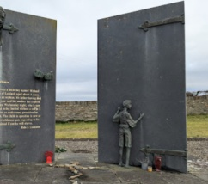
No 2. Thomas Traynor  52.804367, -6.732559 | 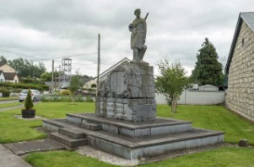
No 3. Masters Voice  51.734157, -8.482557 | 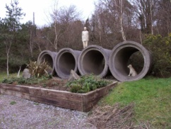
No 4. Hanafin  52.145459, -9.717783 | 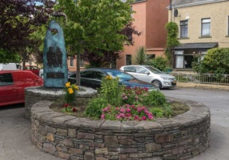
No 5. BobbyJo  53.470213, -8.500425 | 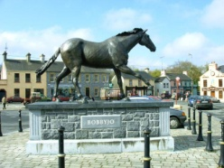
No 6. Connemara Giant  53.466553, -9.739251 | 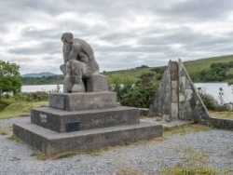
No 7. Doonfeeny Pillar  54.298685, -9.403123 | 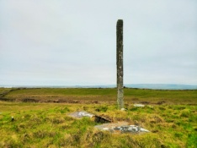
No 8. O’donovan Rossa  51.553455, -9.271405 | 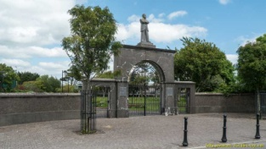
No 9. Titanic Memorial  53.776379, -7.726234 | 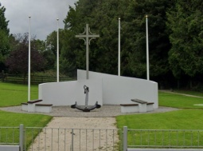
No 10. Cloughaneely Stone  55.140910, -8.097012 | 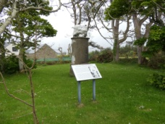
No 11. Pieta Statue  51.59542, -9.711058 | 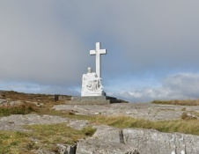
No 12. Ballygeehan Hurling  52.911300, -7.470132 | 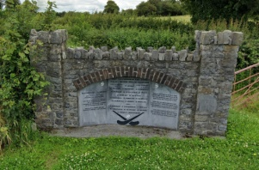
No 13. Blessed Charles  54.378851, -8.112138 | 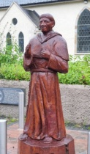
No 14. Spitfire  55.206873, -7.131777 | 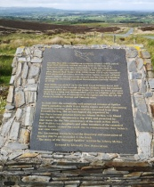
No 15. Alexander Peden  54.841195, -6.082284 | 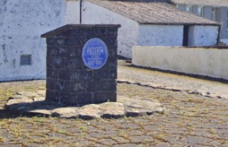

2024 Photo Rally Notes

It is HIGHLY recommended that you print this sheet and take it with you on your ride. It helps to remove any doubt as to what you are meant to be photographing. Your Motorcycle should always be included in the photo. Every year, we receive photos taken at the correct location but of the wrong “thing”. Bringing a copy of this sheet with you, removes all doubt about the photograph subject.

Rider Etiquette.
PLEASE be respectful when you are visiting any of the locations we use. Do NOT ride over grass, ride into private property, ride along footpaths , park in the middle of footpaths orgenerally be anti-social ,inconsiderate or make a nuisance of yourself at locations. There are over 100 riders visiting these locations. It doesn’t take too many motorcycles riding over grassy areas to make it a real mess…and then we start getting complaints. Yes, we have had issues and been contacted in the past

Uploads

Please make our job easier by ONLY uploading a SINGLE photo of each location showing your motorcycle as well. Uploading multiple shots of the same location makes it difficult for the back room staff as they have to look through multiple duplicate photos in the album to perform a count. When we have about 150 albums to review, it seriously slows things down. Also, please, do not upload photos taken by drone. It can be very difficult for us to identify the location from the resulting photo and we end up having to email to ask “where is that”? Also, take a “subject reflected in my mirror” photo if you want, but keep it for yourself and don’t upload it. Again, it can make it hard to identify locations. You cannot delete a photo once it has been uploaded. You have to email to get it deleted.

Locations
Whilst we have taken as much care as possible with the location data, whilst we check and double check, mistakes do sometimes occur in the transition from documents to maps to websites etc. Any mistakes in the data will come to light early in the rally. Always keep an eye on the Website and Facebook for any location corrections.

Finally

Remember, there is no competitive element at all to this event. If you want to ride to all the locations as soon as possible or in one big ride, fine. If you want to take the entire allotted timeframe in multiple days out, that’s ok too. During your ride, you will possibly encounter many roads you have not ridden on before and are therefore unfamiliar with. That’s all part of the fun. But remember, Ride safe, Ride sensibly and enjoy yourself!

IBA Ireland Team.

